AIR POLLUTION

Pollution comes in many forms, smoke, haze, dust, odors, corrosive gases, noise, and toxic compounds are among our most widespread pollutants.

- sulfur dioxide, irritate our eyes and lungs;
- fine particulates penetrate deep into our lungs;
- airborne metals enter our blood stream

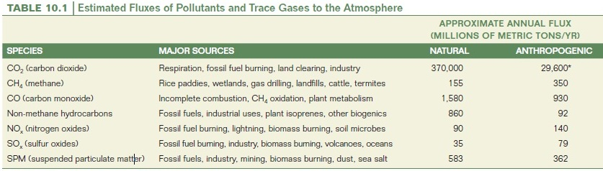

- Sulfur dioxide, nitrogen oxides, carbon monoxide, ozone (and its precursor volatile organic compounds), lead, and particulate matter. These six are referred to as conventional or criteria pollutants.

- Many pollutants come from a point source, such as a smokestack. Fugitive, or nonpoint-source, emissions are those that do not go through a smokestack.

- Primary pollutants are substances that are harmful when released. Secondary pollutants, by contrast, become harmful after they react with other gases or substances in the air e.g. photochemical oxidants and atmospheric acids.
- Studies of air pollutants over southern Asia reveal that a 3 km thick cloud of ash, acids, aerosols, dust, and smog covers the entire Indian subcontinent for much of the year.

- Produced by forest fires, the burning of agricultural wastes, and dramatic increases in the use of fossil fuels, the Asian smog layer cuts the amount of solar energy reaching the earth’s surface beneath it by up to 15 percent, could disrupt monsoon weather patterns and cut rainfall over northern Pakistan, Afghanistan, western China, and central Asia by up to 40 percent.

- “Asian Brown Cloud” drifts out over the Indian Ocean at the end of the monsoon season; it cools sea temperatures and may be changing regional climate patterns in the Pacific Ocean as well.

Sources of pollution

- Volcanic activity, vegetation decay, forest fires emitting carbon monoxide, sulphur dioxide and hydrogen sulphide and tiny particles of solids or liquids sprayed from the seas and land by wind.

- Man-made sources are:
Gases, mists, particulates and aerosols emitted by burning agricultural wastes, industries and other chemical and biological processes used by man.
Primary Pollutants
Five primary pollutants which together contribute more than 90 per cent of global air pollution:

- Carbon monoxide, CO
- Nitrogen oxides, NO_{X}
- Hydrocarbons, HC
- Sulphur oxides, SO_{X} and
- Particulates.

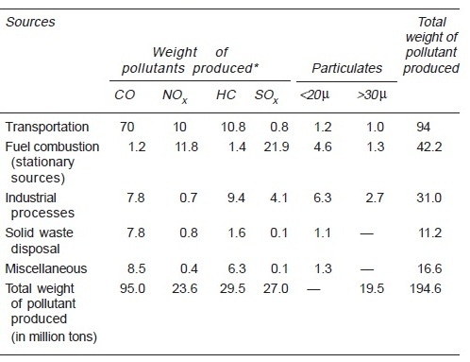
Sources of air pollution (million tons per year)

Particulate

- Small solid particles and liquid droplets are collectively termed particulates.

- Every year natural sources discharge 800–2,000 million tons and man-made sources 200–500 million tons of particulates.

- Particulates range in size from 0.0002 to 500 µ

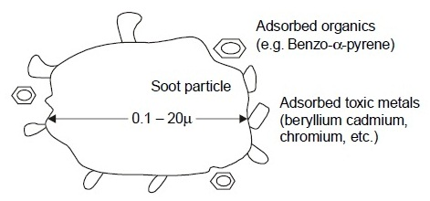

A soot particle

Control of Particulate Emissions

- The removal of particulate matter is carried out by Electrostatic Precipitator.

- Electrostatic precipitator is based on the principle that aerosol particles acquire charge when subjected to an electrostatic field.

- The charged particles are attracted to a grounded surface from which they are recovered.
B. Carbon Monoxide, CO

- It is a colourless, odourless and tasteless gas which is injurious to our health.

- Diesel and petroleum engines are primarily responsible for about 70 per cent of CO emissions.

Produced due to following three reasons

- Incomplete combustion of fuel or carbon containing compounds

2C + O₂ 2CO

- Reaction of carbon dioxide and carbon-containing materials at elevated temperatures in industries, e.g. in blast furnaces

CO₂ + C 2CO

- Dissociation of carbon dioxide at high temperatures

dissociation
CO₂ CO + O

Sinks

- Part of Carbon monoxide is lost in the upper atmosphere.

- The major sink is soil micro-organisms. (28 kg of soil sample can completely remove 120 ppm carbon monoxide from ambient air in 3 hours)
Control of CO, HC, NOx pollution

- Use of catalytic converters in the internal combustion engines of automobiles

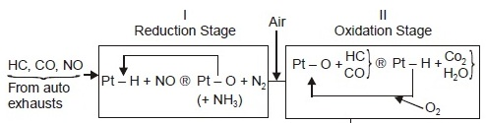

Pt–H = Platinum hydrogen compound;
Pt–O = Platinum oxygen compound

C. Nitrogen Oxides, NO_{X}

Mix of nitric oxide and nitrogen dioxide (NO and NO₂ respectively)

Formation of NO and NO₂ are as follows, inside automobile engines

1210 – 1765 deg cent

N₂ + O₂ 2NO
(nitric oxide)

2NO + O₂ 2NO₂

Exhaust consists of NOx which is converted to HNO₃, also known as acid rain.

NO₂ + O₃ NO₃ + O₂
(nitrogen trioxide)

NO₃ + NO₂ N₂O₅
(nitrogen pentoxide)

N₂O₅ + H₂O 2HNO₃
D. Hydrocarbons and Photochemical Smog

- Primarily CH₄, produced by bacteria formed by anaerobic decomposition of organic matter in water, sediments and soil.
- Domestic animals (cattle, buffaloes, etc.) contribute methane to the atmosphere each year.

- Automobiles are significant sources of hydrocarbons.

bacteria
2 {CH₂O} CO₂ + CH₄

- A chain reaction proceeds where hydrocarbon participate in photochemical reactions In presence of ozone, carbon monoxide, nitrogen oxides.
- The harmful products in the chain reaction are NO₂ and aldehyde, R CHO.
- A side reaction also follows by another route through the aldehyde, R CHO; it gives an injurious end product, peroxy acyl nitrate (PAN) which is a strong eye irritant.
- These reactions lead to photochemical smog formation, which is characterized by brown hazy fumes
E. Sulphur Dioxide, SO₂

- Volcanic eruption is the major source of SO_{X} pollution.

- Coal-fired power stations also contribute SO_{X} pollution

S + O₂ SO₂
(sulphur dioxide)

2SO₂ + O₂ 2SO₃
(sulphur trioxide)

Soot particles containing metal oxides; catalyze the oxidation of sulphur dioxide to trioxide.

H₂O
SO₂ + O₃ SO₃ + O₂ H₂SO₄ (H₂SO₄)_{n}
(sulphur trioxide) (aerosol droplet)

soot
SO₂ + ½O₂ SO₃ H₂SO₄ (H₂SO₄)_{n}
(aerosol droplet)

Control of SO_{X} Pollution

2CaCO₃ + 2SO₂ + O₂ 2Ca SO₄ + CO₂

The process is known as chemical scrubbing.

Soot particles

Soot particles originate from fuel combustion and consist of highly condensed product of polycyclic aromatic hydrocarbon (PAH)—roughly 100 condensed aromatic rings. The hydrogen content of soot is 1–3 per cent and oxygen content 5–10 per cent due to partial surface oxidation. Due to large surface area, soot acts as a carrier for toxic organics, e.g. beryllium, cadmium, chromium, manganese, nickel, vanadium, etc.
GREENHOUSE EFFECT (GLOBAL WARMING)

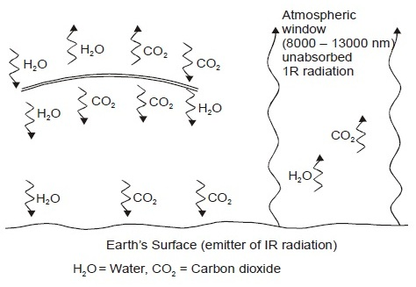

Greenhouse effect

- The carbon dioxide level in air has increased from 280 ppm (pre-Industrial) to 350 ppm at present.
- Fossil fuel (petrol, diesel, coal) combustion is the major source of increase of carbon dioxide level increasing at the rate of 1–2 per cent per year.
- At this rate of increase, the earth’s surface temperature may rise as much as 2° C in the next 100 years.
- However, nature has its check and balance system as ocean and plants are the important sinks.
Effect of greenhouse effect

- Wheat production will badly suffer.
- Biological productivity of the ocean will fall due to warming of the surface layer.
- Another disastrous effect is the rise in sea levels by as much as 15 cm in the next 100 years due to partial melting of polar ice caps.

Other Greenhouse Gases

- Carbon dioxide 50 per cent; Methane 19 per cent;
- Chloroflurocarbons 17 per cent; ozone 8 per cent;
- Nitrous oxide 4 per cent; water vapour 2 per cent.
OZONE HOLE

- Exhaust gases from jet aircrafts nitric oxide (NO), nitrogen dioxide (NO₂), etc. which immediately react with ozone.

O₃ + NO O₂ + NO₂
(nitric oxide) (nitrogen dioxide)

O₃ + NO₂ O₂ + NO₃
(nitrogen trioxide)

- In presence of ultraviolet radiation (200 nm) from the sun, CFC breaks up into chlorine-free radical (Cl) which readily consumes ozone.

UV radiation
CFCl₃ CFCl₂ + Cl•

Cl• + O₃ ClO• + O₂

ClO• + O Cl• + O₂

- CFC slowly passes from troposphere and stratosphere and once there, they stay for 100 years.
- It is estimated that one molecule of CFC consumes one lakh molecules of ozone.
- In 1979 ozone hole was observed in the sky over Antarctica—here ozone layer thickness was reduced by 30 per cent.
- The Kyoto Treaty (1997) for reducing greenhouse gas emissions by developed countries was signed by all these countries except USA.
El NINO

- Greenhouse effect is an atmospheric warming phenomenon while El Nino is an ocean warming phenomenon.
- Under normal conditions the water of the Eastern Pacific off Ecuador, Peru and Chile is cooler by 10° C than the waters of the Western Pacific. Cold waters, rich in nutrients, spring from the deep layers of the ocean.
- The trade winds blow along the equator from Southeast Pacific towards West pushing warm waters out to the ocean. But once every three to five years the trade winds reverse their direction, i.e. from west to east thereby pushing warm waters to the east. As a result, the Eastern Pacific water warms up by about 4° C (24° to 28° C).
- It not only kills fish but warms the air which lowers the atmospheric pressure and sparks storms and heavy rainfall along Chile coast and spreading up to Southern California.

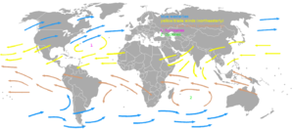

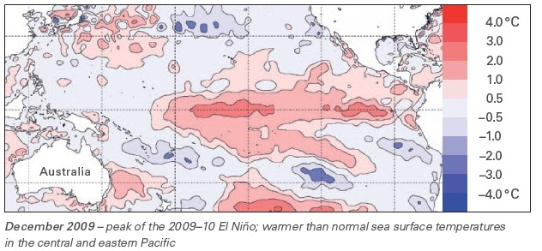

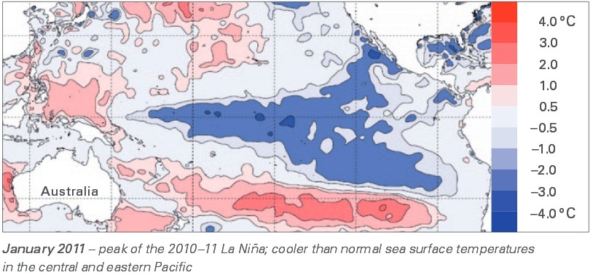
Air pollution status in India

- Pollution hotspots are
  - Delhi the fourth most polluted city in the world.
- Ahmadabad’s air is most noxious- harmful/poisonous flowed by Kanpur, Solapur and Lucknow with small particulate levels (PM10) 3-4 times the standard of 60 microgram per cubic meter.

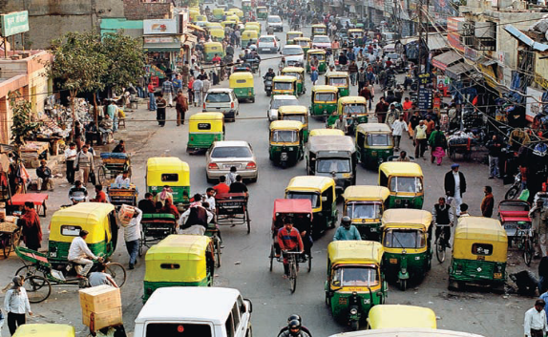
- Sharp increase of NO₂ have been noticed in a few cities with heavy vehicular traffic and density as in a few locations in Kolkata and Delhi indicating stronger impact of traffic.

- The Supreme Court also played a vital role protecting the Taj Mahal. Being exposed to sulphur dioxide and suspended particulate matter, the Taj had contracted ‘marble cancer’, a fungal growth that corroded its surface giving it a yellowish tinge.
Air quality monitoring
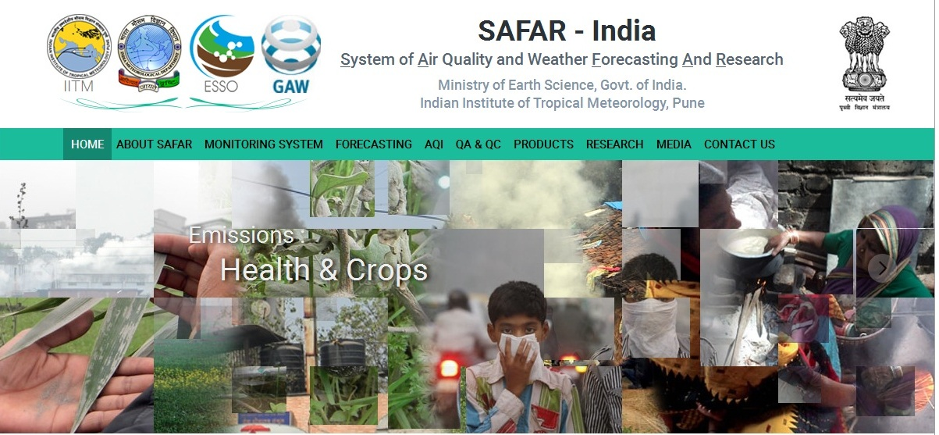

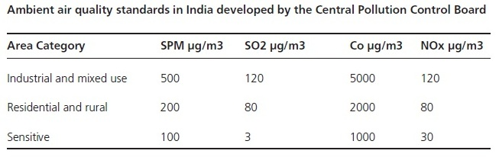

AIR POLLUTION CONTROL

“Dilution is the solution to pollution:”

- The best strategy is reducing production

- Reducing electricity consumption, insulating homes and offices, and developing better public transportation, and more alternative energy
- Particulate removal involves filtering air emissions. In power plants, electrostatic precipitators are the most common particulate controls.
- Switching from soft coal with high sulfur content to low-sulfur coal is the surest way to reduce sulfur emissions. But high-sulfur coal is often used because it is cheap.
- Nitrogen oxides (NOx) can be reduced in both internal combustion engines and industrial boilers by as much as 50 percent by carefully controlling the flow of air and fuel.
- The catalytic converter on your car uses platinum-palladium and rhodium catalysts to remove up to 90 percent of NOx, hydrocarbons, and carbon monoxide at the same time.
- Hydrocarbon controls mainly involve complete combustion or the control of evaporation.
Clean
flue gas
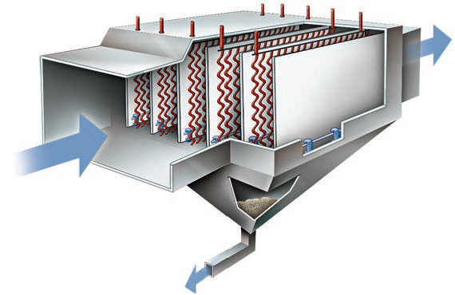

Separator
plates
Particle-laden
flue gas

Fly ash to the storage silo

Electrostatic precipitators
- Clean air legislation is controversial but extremely successful

- Costs of pollution have been absorbed by the public, which breathes or grows crops in polluted air, rather than by polluters themselves. Rules to control pollution have often sought to make polluters pay for pollution control, in order to reduce public losses in sickness, death, degraded resources, and other costs associated with pollution. Naturally, emitters of pollutants have objected to these rules. It is easier and more profitable to externalize the costs of pollution, and let the public absorb the expenses.

- The Air (Prevention and Control of Pollution) Act was legislated in 1981. The Act provided for prevention, control and abatement of air pollution. In areas notified under this Act no industrial pollution causing activity could come up without the permission of the concerned State Pollution Control Board. After the Bhopal disaster, a more comprehensive Environment Protection Act (EPA) was passed in 1986.

  - Putting a greater emphasis on pollution prevention rather than control.
  - Reducing the use of fossil fuels
  - Improving the quality of vehicular fuel
  - Increasing the use of renewable energy

- Trading pollution credits is one approach

- One of the approaches is a market-based “cap-and-trade” system. In this approach, the EPA sets maximum emission levels for pollutants. Facilities can then buy and sell emission “credits,” or permitted allotments of pollutants. Companies can decide if it’s cheaper to install pollution control equipment or to simply buy someone else’s credits.
THE ONGOING CHALLENGE

- Pollution persists in developing areas

- Lead level amongst the children in Mexico is quite high
- Many of the industries in China do not have air pollution control.
- Seven of the ten cities in the world with the worst air quality are in China. Shenyang, an industrial city in northern China, is thought to have the world’s worst continuing particulate problem,

- Many places have improved

- The biggest problem in Delhi is vehicle emissions, which contributed about 70 percent of air pollutants (followed by industrial emissions, at 20 percent, and burning of garbage and firewood).

- Twenty years ago, Cubatao, Brazil, was described as the “Valley of Death,” one of the most dangerously polluted places in the world.

- The state of São Paulo invested about $100 million and the private sector spent twice as much to clean up most pollution sources in the valley. Particulate pollution was reduced 75 percent, ammonia emissions were reduced 97 percent, hydrocarbons that cause ozone and smog were cut 86 percent, and sulfur dioxide production fell 84 percent.
Water Resources

- 71% of the earth’s surface is covered by water
- 97% of the total water available on earth is found in oceans
- 3% is fresh water and 2.997% is locked in ice caps or glaciers.
- only 0.003% of the earth’ total volume of water is easily available

Water Pollution

Any physical, biological, or chemical change in water quality that adversely affects living organisms or makes water unsuitable for desired uses can be considered pollution.

Symptoms of water pollution

- Bad taste of drinking water,
- Offensive smells from lakes, rivers and ocean beaches,
- Unchecked growth of aquatic weeds in water bodies (eutrophication),
- Dead fish floating on water surface in river, lake, etc.
- Oil and grease floating on water surface.

Water Pollutants

- Organic pollutants,
- Inorganic pollutants,
- Sediments,
- Radioactive materials, and
- Thermal pollutants.
Causes of water pollution

- Disease-causing agents e.g. bacteria, viruses, protozoa and parasitic worms that enter water from domestic sewage and untreated human and animal wastes.

- Oxygen depleting organic wastes that can be decomposed by aerobic bacteria. BOD – Biochemical oxygen demand increases. Oxygen deficiency starts anaerobic respiration process and produces chemicals that have a foul odour and an unpleasant taste.

- Inorganic plant nutrients e.g. nitrate and sulphates cause excessive growth of algae and other aquatic plants. (eutrophication)

- Water-soluble inorganic chemicals e.g. acids, salts and compounds of toxic metals such as mercury and lead. High levels of these chemicals can make the water unfit to drink.

- Organic chemicals, which include oil, gasoline, plastics, pesticides, cleaning solvents, detergent and many other chemicals.

- Hot water (higher by 15^{O}C) let out by power plants and industries. The warm water not only decreases the solubility of oxygen but changes the breeding cycles of various aquatic organisms.

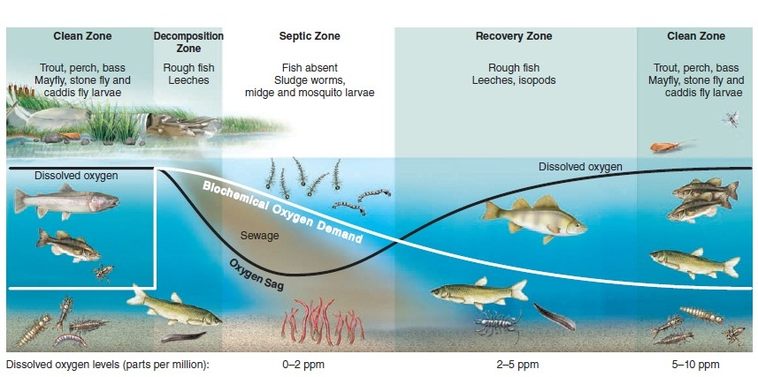

Downstream relationship of BOD and oxygen sag

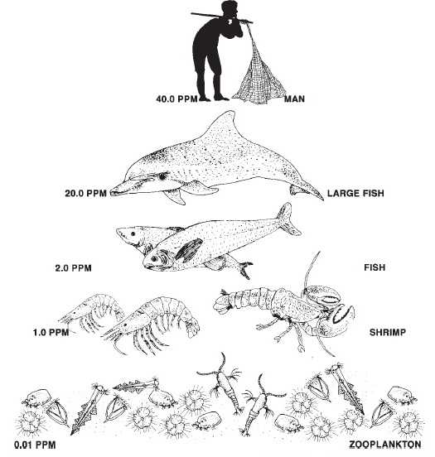

Bioaccumulation and Biomagnification
Groundwater pollution

- Urban run-off of untreated or poorly treated waste water and garbage
- Industrial waste storage located above or near aquifers
- Agricultural practices such as the application of large amounts of fertilizers and pesticides,
- Leakage from underground storage tanks containing gasoline and other hazardous substances
- Leachate from landfills
- Poorly designed and inadequately maintained septic tanks
- Mining wastes

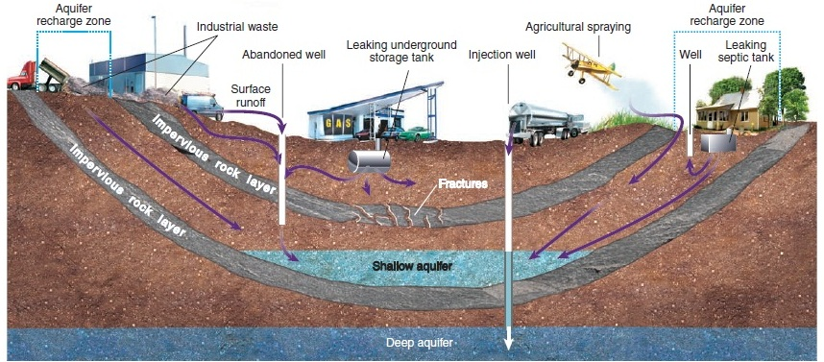

Sources of groundwater pollution

Arsenic poisoning from contaminated groundwater have been reported from West Bengal in what is known today as the worst case of groundwater pollution.

Two theories

- Arsenic probably originates in the Himalayan headwaters of the Ganga and the Brahmaputra rivers and has been lying undisturbed beneath the surface of the region’s deltas for thousands of years in the thick layers of fine alluvial mud across the banks of these rivers.

- Pyrite oxidation hypothesis. Due to the lowering of the water table below the deposits, arseno-pyrite which is oxidized in a zone of the aquifer releases arsenic as arsenic adsorbed on iron hydroxide. During the subsequent recharge period, iron hydroxide releases arsenic into groundwater.
POLLUTION CONTROL

- The cheapest and most effective way to reduce pollution is to avoid producing it or releasing it in the first place.

- Industry can reduce pollution by recycling or reclaiming materials that otherwise might be discarded in the waste stream.

- Nonpoint sources are often harder to control than point sources

- Farmers have long contributed a huge share of water pollution, including sediment, fertilizers, and pesticides that flow from fields.

- In urban areas, reducing waste that enters storm sewers is essential.

How do we treat municipal waste?
Three levels

- Primary treatment physically separates large solids from the waste stream with screens and settling tanks.
- Secondary treatment, in which aerobic bacteria break down dissolved organic compounds.
- Tertiary treatment removes dissolved metals and nutrients, especially nitrates and phosphates, from the secondary effluent. Allowing effluent to flow through a wetland or lagoon can remove nitrates and phosphates.

Natural wastewater treatment can be an answer?
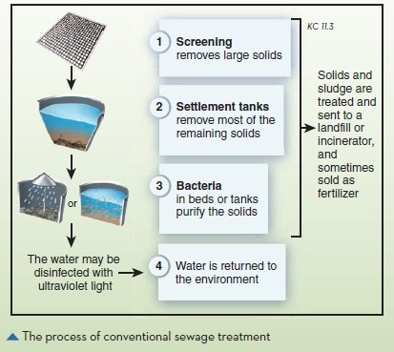

Constructed waste water systems
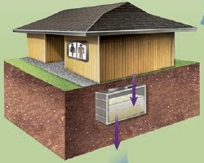
- Anaerobic (oxygen-free) tanks: here anaerobic bacteria convert nitrate (NO₃) to nitrogen gas (N₂), and organic molecules to methane (CH₄). In some systems, methane can be captured for fuel.


- Aerobic tanks Oxygen is mixed into water, supporting plants and bacteria that further break down and decontaminate waste. Remaining solids settle out.


- Gravel-bedded wetland: beneficial microorganisms and plants growing in a gravel bed capture nutrients and organic material. In some systems, the wetland provides wildlife habitat and recreational space.

- Disinfection Ozone, chlorine, UV light, or other methods ensure that no harmful bacteria remain. Water can then be reused or released.

